Peripheral IV

Positioning:
Arm abducted and externally rotated
The probe indicator and the screen indicator should be on the same side
Probe:
Linear (vascular) in short-axis view
Views:
1. Clip of compressing and holding compression on the vessel to demonstrate that it is a
a vein and not an artery
2. Clip of mapping the vein (tracing the vein proximally and distally)
3. IF POSSIBLE, a picture of the needle in the vein

Vein options:
- Antecubitals: usually if the nurse can’t get them, you won’t find anything here
- Basilic vein: this is the one you’re going to use most often. It’s BIG, and not associated with a nerve or artery. The downside is that it’s medial so a little more awkward positioning-wise.
- Cephalic vein: great if you can find one, but most of our difficult IV patients won’t have a useable one. Located laterally on the arm, gets smaller more proximally
- Brachial veins: deep, usually multiple veins surrounded by multiple arteries and nerves. So it hurts, and it’s hard to avoid the other vessels. Also, these have the highest rate of infiltration, especially with pressure.
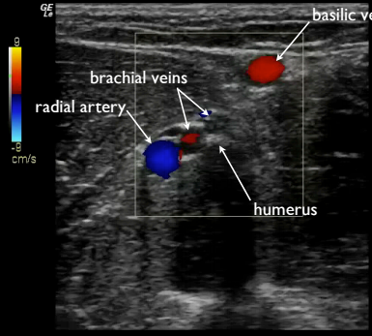
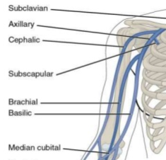

Peripheral IV Technique and Tips

1. You will need the following equipment:
Long peripheral IV catheter (kept in MD office) Extra gauze
J-loop Flush
Tourniquet Tape
Tegaderm Alcohol prep
Get all the equipment unwrapped and ready to go before finding a vein

2. Procedure
1. Place tourniquet and position the arm.
2. With the probe in short axis, start just proximal to the antecubital fossa and find the brachial vessels. Then, to find basilic vein, slide medially around the arm. To find cephalic, slide laterally around the arm. The brachials will be in the midline of the arm, deeper than the other vessels.
3. A good vein should be at least 3mm diameter and less than 1.5 cm deep.
4. Compress the vessel and hold compression to confirm it is a vein and not an artery
5. Map the vessel: trace it proximally and distally to confirm no branches, valves, other things that will make threading catheter difficulty
6. Once mapped, pick the most distal place for insertion which allows you to avoid the structural problems noted in #5.
7. Prep the skin just in front of the probe. DO NOT MOVE THE PROBE DISTALLY AFTER PREP IS COMPLETE.
8. Adjust your probe positioning and screen depth so that the vessel is in the very center of the screen, both widthwise and depthwise
9. Choose an angle of approach appropriate to the depth of the vessel. You will get a gestault for this after doing a few, but in general, if the vessel is 1.5cm deep, I usually enter at a little less than 45degrees to the skin. Enter at a shallower angle for more superficial vessels, steeper angle for deeper vessels.
10. Puncture just through the skin, then angle the probe back at the needle to find the tip.
11. Once the tip is found, slide the probe away from the needle until the tip disappears, then advance the needle until the tip reappears. Repeat this until the needle enters the vessel.
12. Once the needle tip is in the vessel, change your angle a little bit to keep the needle tip at the same depth while you continue the technique described in step 10 to advance the needle further into the vein. You want about 1 cm of needle in the vein before advancing the plastic catheter
13. Once you have advanced the needle further into the vein, put the probe down and advance the plastic catheter into the vessel

Trouble shooting:
Got a flash but can’t thread the catheter: probably didn’t advance the needle far enough before trying to thread.
If you’ve lost your needle tip: slide the probe away from the needle until you think you’re off the tip. Then, gently jiggle the needle while sliding the probe towards the needle until you see the tip wiggling. Alternatively, you can try to switch to long axis to see where the tip is.

