Transvaginal pelvic

Positioning:
Lay patient flat, supine position
Use OB stretcher if possible
Bladder should be EMPTY, have pt urinate first

Probe:
Endocavitary (“transvaginal”) probe
You MUST be on the “OB” exam. It should default to OB exam, but if not, hit the exam
button to put it into OB

Views:

1. Longitudinal view
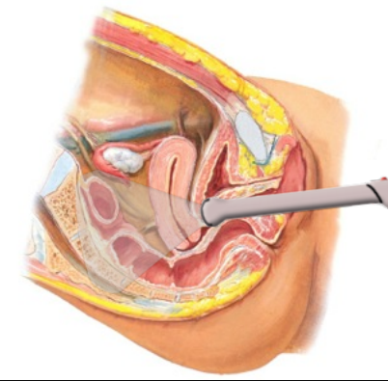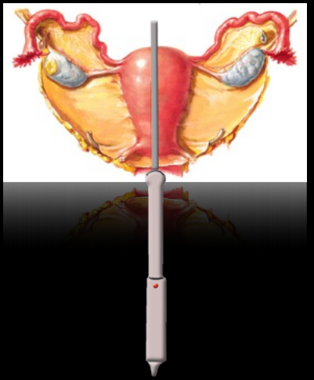
2. Transverse view
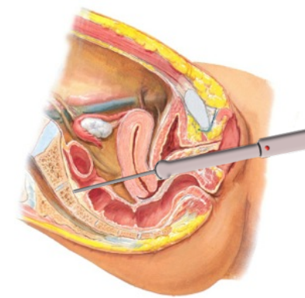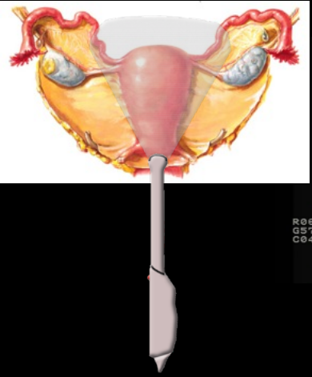
3. Right adnexa (in transverse view)
3. Left adnexa (in transverse view)

Transvaginal Technique and Tips

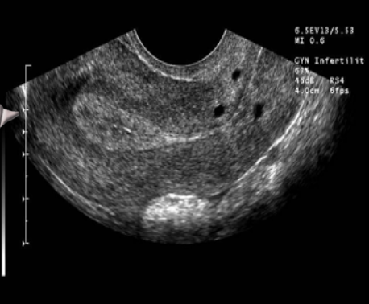
1. Longitudinal view
Indicator to ceiling. Push the probe handle towards the floor slightly to angle the internal part of the probe up towards the ceiling. Fan left to right through the uterus looking for an IUP and fluid in the Pouch of Douglas.

2. Transverse view
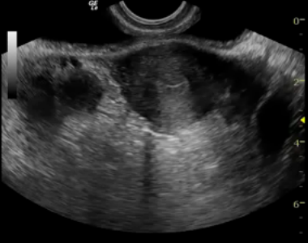
After finding the uterus in the sagittal view, put it in center of the screen and slowly rotate probe counter-clockwise so indicator is pointing to pt’s rt. Fan head to toe all the way through the uterus.

3. Right adnexa
In transverse view, with indicator to pt’s right angle the probe into the right adnexa, keeping edge of uterus in view as a landmark. Fan head to toe through the entire right adnexa looking for ovaries or masses.

4. Left adnexa
In transverse view, with indicator to pt’s right angle the probe into the left adnexa, keeping edge of uterus in view as a landmark. Fan head to toe through the entire left adnexa.

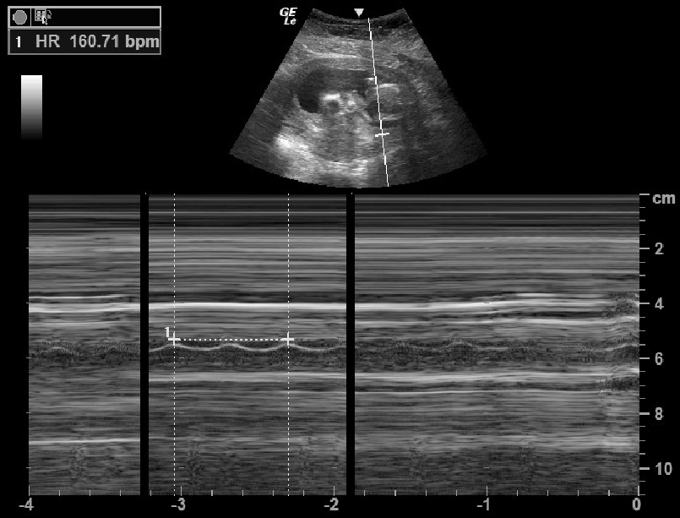
5. Calculating Fetal Heart Rate (FHR)
Fan through the fetus until you locate the heart. You can also zoom in to see better. Press “M Mode” and use the mouse pad to move the line until it goes through the heart beat. Then hit “M Mode” again to get your tracing that looks like a sine wave. Then
hit “Freeze”. Now hit “Measure” (remember you MUST be on the OB exam mode to get the FHR calculation). Select “FHR”- a vertical line willl appear on the screen. Move the vertical line to one of the troughs of the sine wave. Then hit select- a second vertical line will appear. On the Sonosite or Zonare, put the second line one trough away. For GE, put the second line TWO troughs away from the first. The FHR measurement will appear on the screen.

Trouble shooting:
Make sure the patient has an empty bladder.
If you can’t find the uterus, try angling the probe towards the ceiling as described in step one. If you still can’t find the uterus, you may have inserted the probe too far, pull out a little bit. If you still can’t find the uterus, it may be retroverted; try angling the probe towards the floor, but even then a retroverted uterus can be difficult to see.

A FIRST FINDING ON BEDSIDE ULTRASOUND CONSIDERED POSITIVE FOR IUP IS A YOLK SAC WITHIN THE UTERUS.

