Transabdominal pelvic

Positioning:
Lay patient flat, supine position

Probe:
Abdominal (curvilinear) or cardiac (phased array)
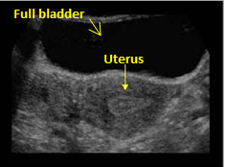
You MUST be on the “OB” exam. Press the “Exam” key, and scroll down to choose “OB”.
Make sure you switch it back to “Abdominal” afterwards.

Views:
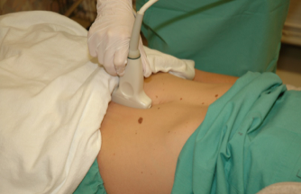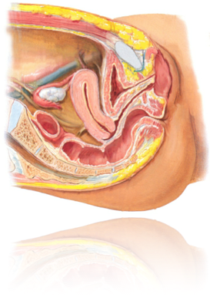
1. Longitudinal view
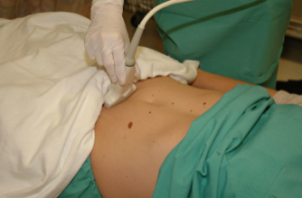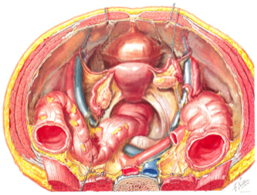
2. Transverse view

3. Right adnexa (in transverse view)
3. Left adnexa (in transverse view)

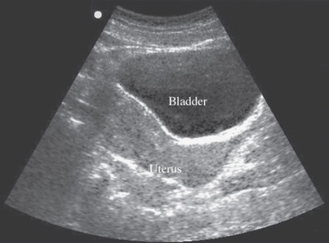
Transabdominal Technique and Tips

1. Sagittal view
Indicator to the patient’s head, just above pubic bone,
point down into pelvis. Fan left to right all the way
through the uterus

2. Transverse view
After finding the uterus in the sagittal view, put it in
center of the screen and slowly rotate probe
counter-clockwise so indicator is pointing to pt’s rt.
Fan head to toe all the way through the uterus
When the bladder is empty, the fundus of the uterus
can fold up and over the empty bladder, so you may
see uterine fundus anterior to the bladder

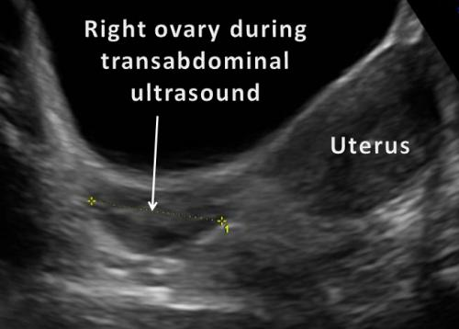
3. Right adnexa
In transverse view, with indicator to pt’s right, slide
probe to pt’s right, keeping edge of uterus in view.
Fan head to toe through the entire right adnexa

4. Left adnexa
In transverse view, with indicator to pt’s right, slide
probe to pt’s left, keeping edge of uterus in view.
Fan head to toe through the entire left adnexa
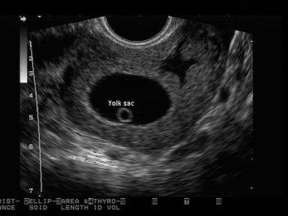
5. Calculating Fetal Heart Rate (FHR)
Fan through the fetus until you locate the heart. You can also zoom in to see better. Press “M Mode” and use the mouse pad to move the line until it goes through the heart beat. Then hit “M Mode” again to get your tracing that looks like a sine wave. Then hit “Freeze”. Now hit “Measure” (remember you MUST be on the OB exam mode to get the FHR calculation). Select “FHR”- a vertical line will appear on the screen. Move the vertical line to one of the troughs of the sine wave. Then hit select- a second vertical line will appear. On the Sonosite or Zonare, put the second line one trough away. For GE, put the second line TWO troughs away from the first. The FHR measurement will appear on the screen.

Trouble shooting:
Make sure the patient has a full bladder to create an acoustic window to look through
Can’t find the uterus? Make sure to aim down into the pelvis

THE FIRST FINDING ON BEDSIDE ULTRASOUND CONSIDERED POSITIVE FOR IUP IS A YOLK SAC WITHIN THE UTERUS.

