FAST

Positioning:
Lay patient flat, supine position
Have patient put hands behind their head if possible
Probe:
Abdominal (curvilinear), or cardiac (phased array)
Linear for pneumothorax
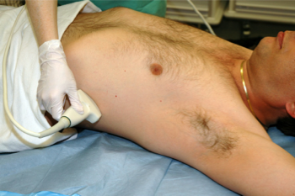
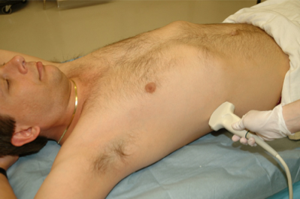
Views:
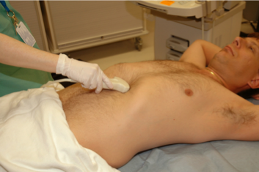
1. Right upper quadrant (RUQ) 2. Left upper quadrant (LUQ)
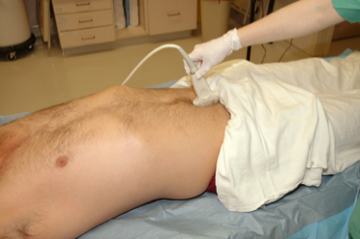

3. Subxiphoid 4. Pelvic/Bladder

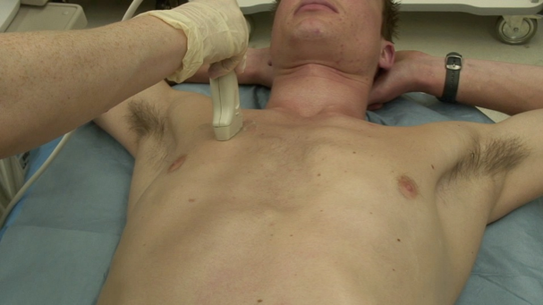
5,6. Thorax for pneumothorax

FAST Technique and Tips

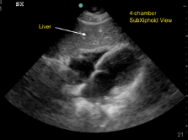
1. Subxiphoid cardiac (Label SX)
Indicator to patient’s right
Go slightly to right of midline and aim through liver
Tuck under xiphoid process, flatten probe
Will need to increase depth
Trouble shooting:
Is the probe flattened out?
Is your depth deep enough?
Try looking through the liver
Push down on the belly to look under rib cage
Have patient take a deep breath in while maintaining the pressure on the probe
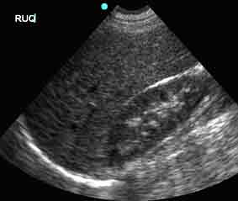
2. RUQ
Indicator to the pt’s head, mid-axillary line
Find Morrison’s pouch and fan ceiling to floor
Slide towards pt’s head to diaphragm for pleural fluid
Slide toward pt’s feet and slightly anteriorly to tip of the liver
Trouble shooting:
See liver but not kidney? Go more towards the bed and feet
Rib in the way? Rotate probe slightly counter-clockwise to get in between ribs
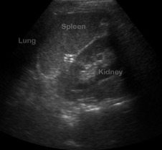
3. LUQ
Indicator to pt’s head, mid-axillary line
Find splenorenal space and fan ceiling to floor
Slide towards pt’s head to diaphgram for pleural fluid
Trouble shooting:
Left side is more “towards the head and towards the bed”
See spleen but not kidney? Go more towards the bed
Rib in the way? Rotate probe slightly clockwise to get in between ribs
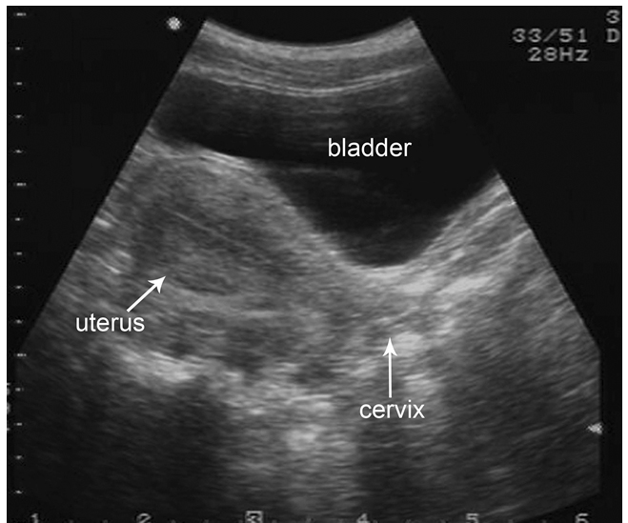
4. Pelvis (Label “PEL”)
Two views:
1: Indicator to pt’s right, aim down into pelvis and fan head
to toe through entire bladder
2: Indicator to pt’s head, aim down into pelvis and fan left
to right through entire bladder
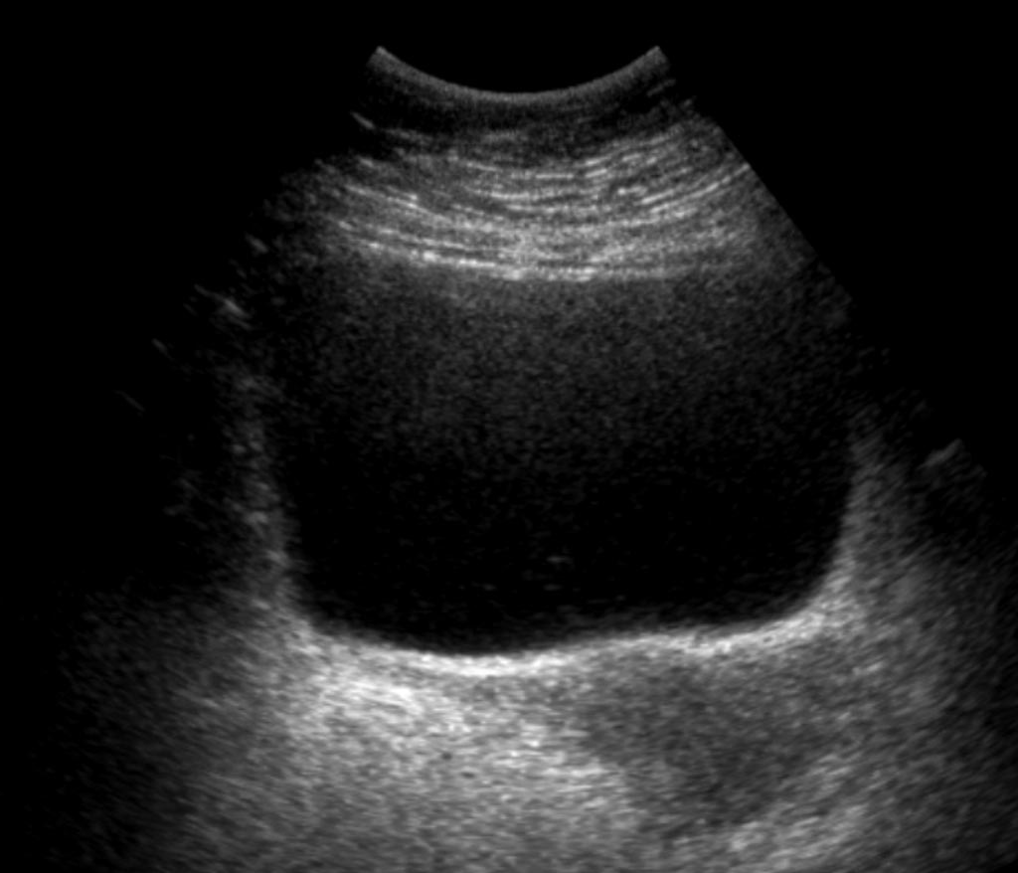
Trouble shooting:
Can’t find bladder? Make sure to slide down to just above
pubic bone and aim towards feet, down into the pelvis
5, 6. Thorax for pneumothorax (Label left and right)
Indicator towards the head in midclavicular line at lung apex
Find a rib, then the pleural line (the first white line just below
the rib)
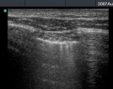
Look for lung sliding and comet tails
Slide towards feet to next few intercostal spaces and repeat
Trouble shooting:
Heart in the way on the left? Move more laterally or
superiorly

