Biliary Ultrasound

Positioning:
Left lateral decubitus position, patient’s right arm up over their head

Probe:
Abdominal (curvilinear) or cardiac (phased array)

Views:
1. Find gallbladder (see back of card)

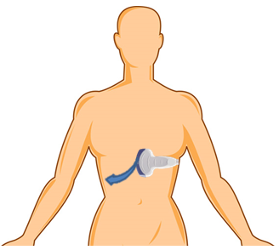

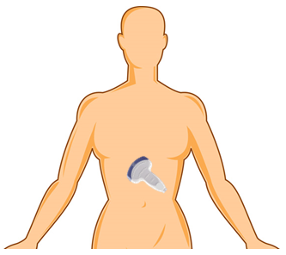
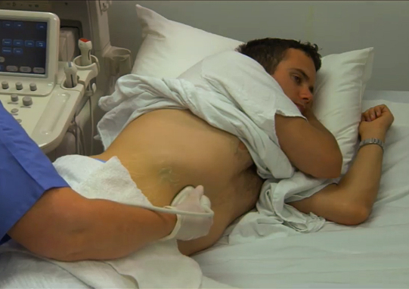
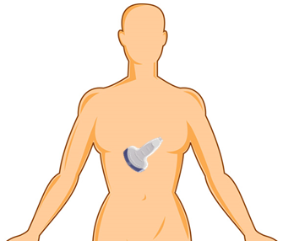

3. Approximate orientation for short axis view and wall thickness
2. Approximate orientation for long axis view and common bile duct

Biliary Technique and Tips

1. Find the gallbladder
Position the patient as described on the front of the card.
Place the probe in the pt’s midline, just under the xiphoid process, slightly to the LEFT of patient’s midline, indicator towards head. Slide or angle cephalad or caudad as needed to move the liver edge into the center of the screen.
Keep this vertical orientation as you sweep just under the costal margin from midline to the
patient’s right, keeping the liver edge in view at all times until the gallbladder appears.
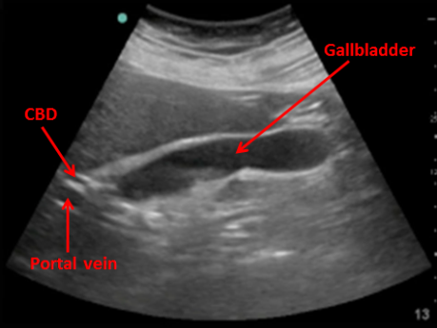
2. Long axis view and CBD
After finding the gallbladder as described above,
you will need to rotate the probe, usually
slightly clockwise, to elongate the gallbladder
out into the long axis view (an oval shape).
Then, fan through the entire gallbladder for stones.
To find the CBD, fan through the gallbladder to find the portion that reaches closest to the bottom of the screen (the neck). Once you found the neck, look at about 8 o’clock and look for the portal vein (usually about a 1cm diameter vessel). Focus in on the portal vein and look for the CBD, a smaller structure running just above it.
Measure the CBD, inside to inside. Use the zoom function for more accurate measurement.
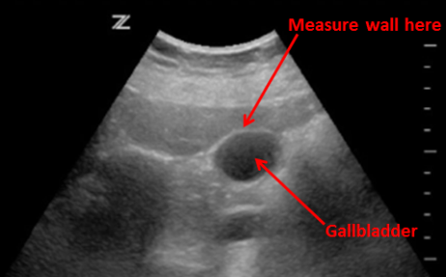
3. Short axis view and wall thickness
Keep GB in the long axis and in center of screen.
Slowly rotate 90 degrees counter-clockwise so the
gallbladder now appears as a circle.
Measure the wall closest to the probe (top of the
screen) in an area where the wall is clearest and easiest to measure. Use the zoom function for more accurate measurement. Fan through the entire gallbladder looking for stones.

4. Ultrasonographic Murphy’s Sign
Move the probe so the GB is in the center of the screen and apply pressure to the GB with the probe. Then move the probe to another nearby area so the GB is no longer in view and push there. A positive Ultrasonographic Murphy’s sign is present if maximal pain was elicited with compression over the gallbladder.
2
3

Trouble Shooting
Can’t find the gallbladder? Don’t forget the left lateral decubitus positioning and to sweep
from just left of midline all the way to the mid-axillary line.
Found the gallbladder but don’t have a clear view? Have patient take a deep breath in and
hold it (you may need to move your probe inferiorly slightly to follow the gallbladder).
Not sure which is CBD? Put color flow over the triad- the one with no flow is the the CBD.

Normal values:
Gallbladder wall: <4mm (usually 6mm or more in acute cholecystitis)
Common bile duct: <4mm + 1 mm for every decade over 40 (e.g. 60 yo limit would be 6 mm)

