DVT

Positioning:
Lay patient flat, supine position
Have pt bend their knee and then rotate outward at the hip into
a frog-leg position
Probe:
Linear

Views:
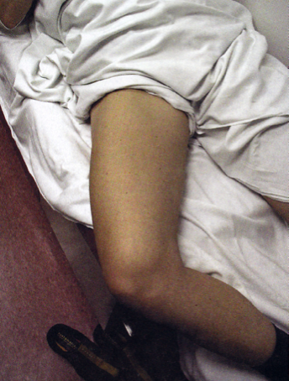
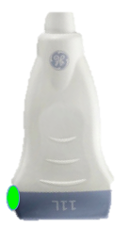

1. Femoral views
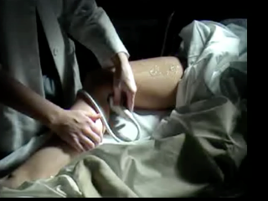

2. Popliteal views

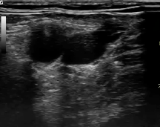
DVT Technique and Tips
CFA
SV
1. Femoral views (Lable right or left FEM)
CFV
Indicator to patient’s right
Start as proximally as possible, just under
inguinal ligament, where there are just 2
vessels visible; the common femoral artery
(CFA) and common femoral vein (CFV)
Taking a video, compress the vein against the
femur until it completely collapses
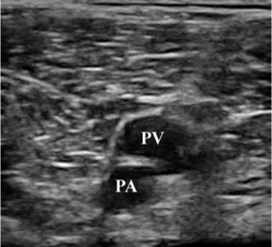
Slide the probe distally past the offtake of the
saphenous vein and compress again
Slide the probe distally until the common
femoral vein splits into the deep and superficial
femoral veins, and then compress again
Continue to follow the vein distally as far as you can,
stopping every few cm to compress the vein again
taking clips each time

2. Popliteal views (Label right or left POP)
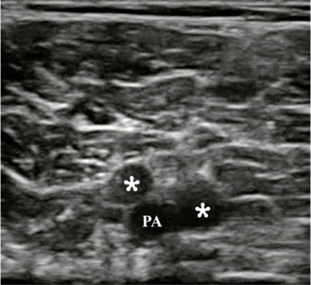
Indicator to patient’s right
Tuck the probe into the popliteal fossa just behind the
knee, locating the popliteal artery and vein
Compress the vein completely
Trace the vein distally until it bifurcates (just a few cm)
and compress again

3. Augmentation (can be done for fem and pop views)
Need a second hand to do this part while taking a clip
Press the “Color” button (just above the 2D button) on
the machine
Use the mouse pad to move the color box over the vein
Use the gain knob to adjust the sensitivity of the color doppler to flow so that the artery is pulsating with color, but the vein is not
Squeeze the calf and look for a flash of color in the vein. This indicates augmentation and
therefore, a lack of obstruction (e.g. DVT) between the probe and the calf. Compare the
degree of augmentation between the two legs.

Troubleshooting
Having trouble applying pressure to the vein?
In the femoral view, make sure to angle the probe slightly laterally as you push,
compressing the vessel between the femur and the probe.
In the popliteal view, make sure the knee is slightly flexed; when the knee is extended, the
ligamentous structures behind the knee prevent compression
If you are able to compress the artery but not the vein, that is indicative of a DVT!

