Cardiac

Positioning:
Flat or rolled over slightly to their left with left arm over their head
Probe:
Cardiac (phased array)
Make sure exam is set to cardiac
Views:
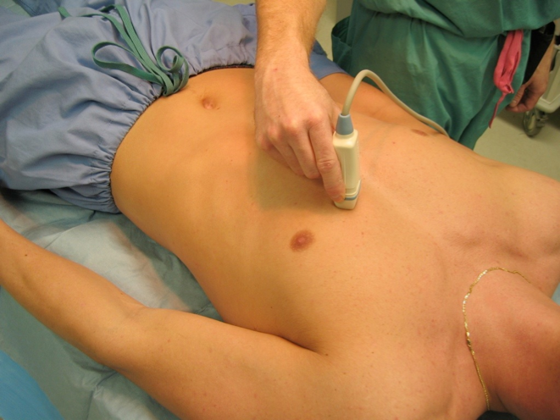
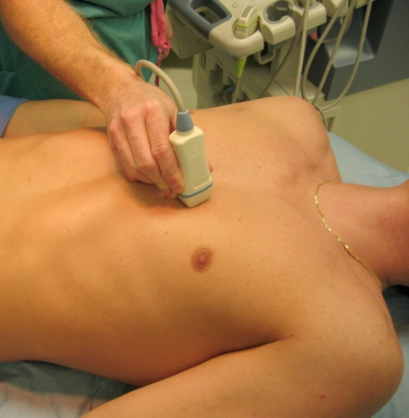

1. Parasternal long (PSL) 2. Parasternal short (PSS)
Indicator to right shoulder Indicator to left shoulder

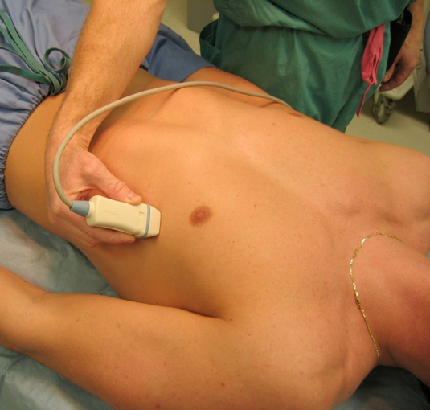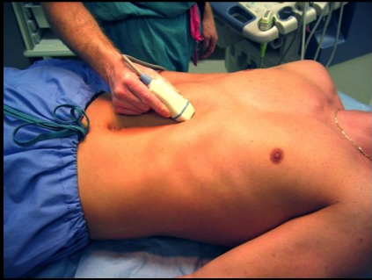
3. Apical 4 Chamber (A4C) 4. Subxiphoid
Indicator to left axilla Indicator to patient’s left
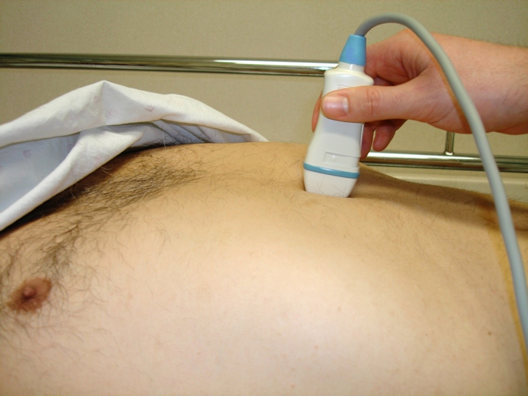

5. IVC view
Indicator to pt’s feet

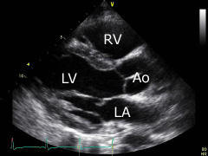
Cardiac Technique and Tips

1. Parasternal long view (PSL)
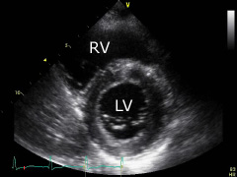
Probe to left of sternum at nipple line. Indicator towards RIGHT shoulder. If you don’t see the heart right away, move up or down a rib space, staying next to the sternum, until you find the heart. Then try fanning or rotating slightly to optimize your view. Good for assessing LV function and aortic root diameter.

2. Parasternal short view (PSS)
With probe in PSL view, rotate probe 90° so indicator pointing at LEFT shoulder. Keep this orientation and slide towards RIGHT shoulder to view aortic valve, then slowly towards LEFT elbow to view mitral valve. Good for assessing concentric wall motion.
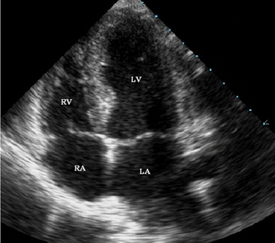
3. Apical 4 chamber view (A4C)
With probe in PSS view slide towards left elbow, keeping
LV in view the entire time, tracing LV all the way to apex.
Then flatten probe so parallel with chest, and aim probe towards right shoulder. Indicator points towards LEFT armpit. In women, trace as far as you can towards apex, then move probe underneath breast into inframammary crease. Good for assessing RV dilation/strain.
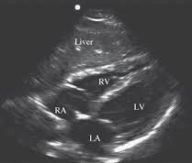
4. Subxiphoid 4 chamber view. (SX)
With probe in the A4C view, slide the probe under the xiphoid process just to right of midline, looking through liver (indicator will point to pt’s left). Flatten probe so parallel to abdominal wall and aim probe under sternum. Best view for looking for pericardial effusion.

5. Subxiphoid IVC view (IVC)
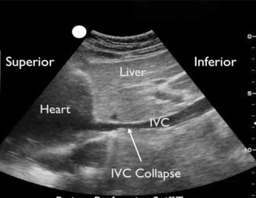
With probe in SX 4 chamber view, move probe so right atrium is in center of screen. Slowly lift probe and point towards spine, watching RA become IVC. Now move probe slightly to pt’s right so IVC is in center of screen, then slowly rotate probe clockwise 90° so indicator is pointing towards pt’s feet, watching the IVC stretch out into long axis. Good for assessing volume status.

Troubleshooting:
Not getting good views? Have the patient roll on left side and bring left arm over head.
Don’t mistake the aorta for the IVC!

Normal values:
Thoracic aorta: ≤ 3.5 cm Fractional shortening: > 25%
IVC inspiratory collapse: > 50% IVC diameter: ≤ 2 cm

