Central IV

Positioning:
Stand at the head of the bed, position your ultrasound in front of you to the patient’s right.
Turn patient’s head to the left. If this causes the vein to be right on top of the artery, you can try having the patient just bend their head to the left and seeing if that position separates the vessels more.
Make sure the indicator on the probe and on the screen are on the same side
Probe:
Linear (vascular) in short-axis view
Views:
1. Short-axis views of the carotid and IJ. Please label both structures.

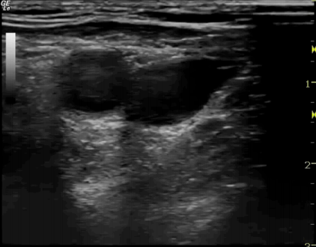
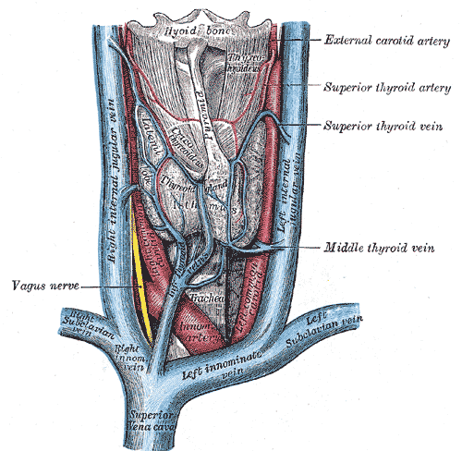

Central IV Technique and Tips

1. You will need the following equipment:
Central catheter kit
Sterile probe cover (kit includes sterile gel)

2. Procedure
1. Ultrasound neck and get positioning and location set before sterilizing
2. Prep and sterile drape the patient as per standard procedure
3. You will need someone to help you put the sterile probe cover on. Have your helper apply non-sterile gel to the probe. Then, hold the probe cover with the opening towards your helper and have them gently lower the probe into the cover. Have your helper than grasp the white cardboard part of the cover, while you grasp the probe and plastic cover and pull, extending the cover over the probe. Secure with the elastic bands in the probe cover kit. Apply STERILE gel to the outside of the probe cover.
4. Find your entry point. I usually end up about mid-neck to give me enough room to work while staying a safe difference from the lung apex. Identify the carotid and IJ. If the IJ is collapsed, you can ask the pt to Valsalva, or you can have a helper hold their legs in the air to increase venous return.
IJ
C
5. Adjust your probe positioning and screen depth so that the vessel is in the very center of the screen, both widthwise and depthwise
6. Note the depth of the vessel (at its center). Insert your needle exactly this distance back from the probe, puncturing just through the skin. Then slide the probe back towards the needle, or angle it back towards the needle to find the tip. Once the tip is located, slide the probe away until it disappears, then advance the needle until it reappears. Continue this process until the needle tip is in the center of the vessel
7. Once the needle tip is in the center of the vessel, put the probe down and complete the central line the way you typically would.

Trouble shooting:
If you’ve lost your needle tip: slide the probe away from the needle until you think you’re off the tip. Then, gently jiggle the needle while sliding the probe towards the needle until you see the tip wiggling. Alternatively, you can try to switch to long axis to see where the tip is.

If the IVC is very collapsed, you can use the angiocath included in the central line kit, rather than the simple metal needle. Procedure is the same, but you advance the catheter in to hold the position in the vessel (replacing the metal needle which can easily puncture through the back wall in a collapsed IJ.)

