Renal

Positioning:
Lay patient flat, supine position
Probe:
Abdominal (curvilinear) or cardiac (phased array)
Views:
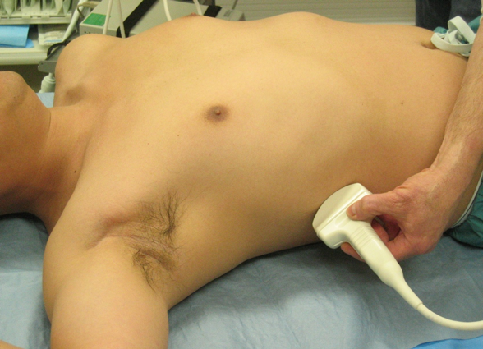
1. Right kidney (long and short axes)

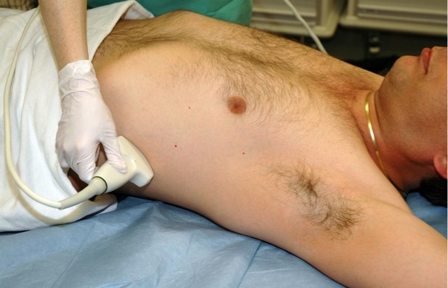
2. Left kidney (long and short axes)
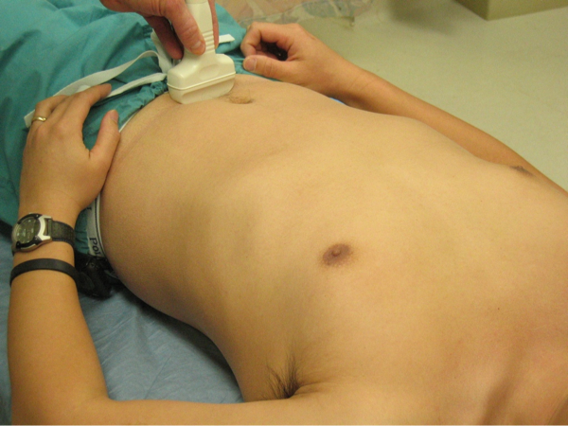

3. Bladder (transverse and sagittal views)
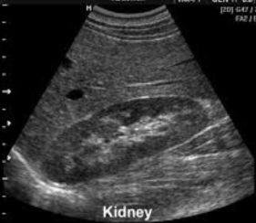
Renal Technique and Tips
Normal long axis

1. Right kidney
Long axis view:
Indicator to patient’s head, mid-axillary line
Fan ceiling to floor through entire kidney
Short axis view:
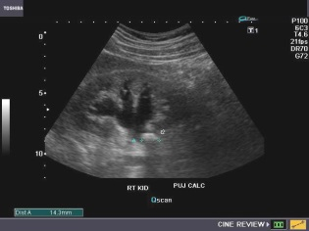
Find kidney in long axis view and get it right in the
Hydronephrosis
center of the screen
Rotate slowly 90 degrees (either way) to get the
short-axis view
Fan head to toe through entire kidney

2. Left kidney
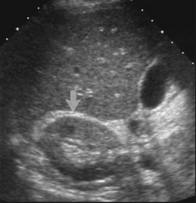
Long axis view:
Indicator to patient’s head, mid-axillary line
Normal short axis
Fan ceiling to floor through entire kidney
Short axis view:
Find kidney in long axis view and get it right in the center of
the screen
Rotate slowly 90 degrees (either way) to get the short-
axis view
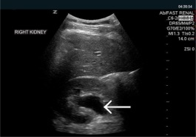
Fan head to toe through entire kidney

Trouble shooting kidneys:
Hydronephrosis
Rib in the way? Angle probe slightly clockwise to get in
between ribs or have patient take a deep breath in
and slide probe slightly towards feet
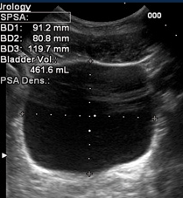
3. Bladder
Transverse view:
Indicator to patient’s right, probe just above pubic bone
Aim down into the pelvis
Fan through entire bladder head to toe
Sagittal view:
Indicator to patient’s head, probe just above pubic bone
Aim down into the pelvis
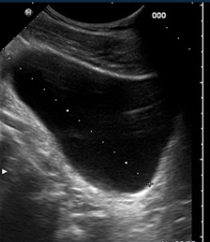
Fan through entire bladder left to right
Measuring bladder volume:
Hit “Calcs” and scroll down to “Volume”
In transverse view measure anterior-posterior and save as “D1”
In transverse view measure left-to-right and save as “D2”
In sagittal view measure head-to-toe and save as “D3”
Trouble shooting:
Can’t find bladder? Aim down towards feet and into pelvis

