Aorta

Positioning:
Lay patient flat, supine position
Probe:
Abdominal (curvilinear) or cardiac (phased array)
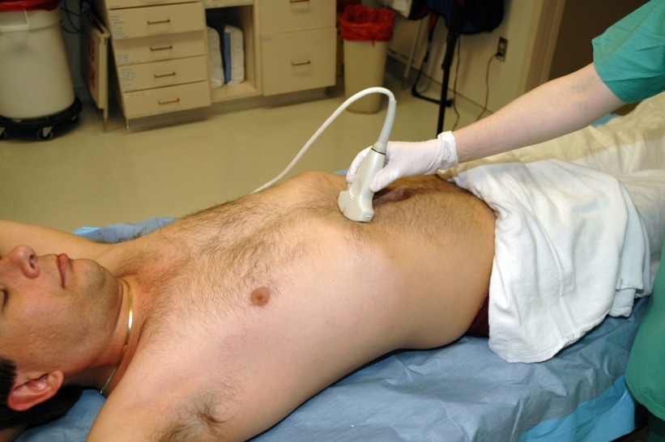
Views:
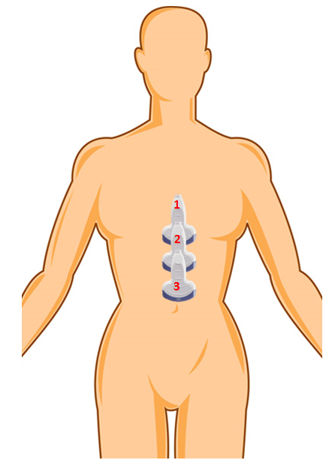

1. Proximal aorta
2. Mid aorta
3. Distal aorta/bifurcation

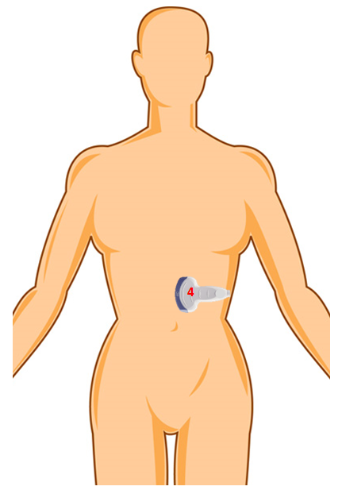

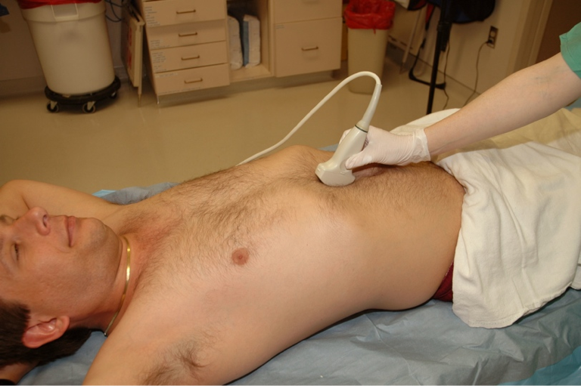

4. Long axis view

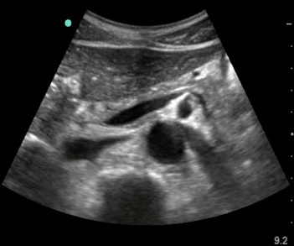
Aorta Technique and Tips

1. Proximal aorta (Label “PAO”)
Indicator to patient’s right
Tuck up under subxiphoid process, aim at patient’s
spine
Look through liver
Freeze and measure the proximal aorta in anterior-
posterior dimension, from outside wall to outside
wall, save a pic of the measurement
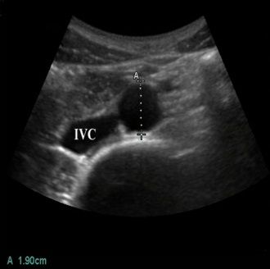

2. Mid aorta (Label “MAO”)
Slide towards the feet, keeping the aorta in view until
you get about ½ way between xiphoid and umbilicus
Freeze and measure the mid aorta in anterior-
posterior dimension, from outside wall to
outside wall, save a pic of the measurement

3. Distal aorta (Label “DAO”)
Slide towards the feet, keeping the aorta in view and find the bifurcation
Move just proximal to the bifurcation
Freeze and measure the distal aorta in anterior-posterior dimension, from outside
wall to outside wall, save a pic of the measurement
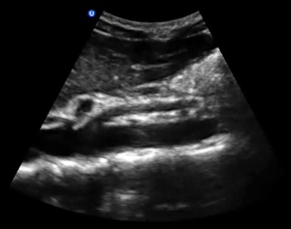
4. Long-axis view
Find the mid aorta as described as above
Position the aorta in the very middle of the screen
and slowly rotate the probe 90 degrees,
watching the aorta stretch out into the long axis

Trouble shooting:
Start at a deeper depth (18 to 22 cm) to make sure you are looking at aorta
Push HARD (most common reason you can’t see the aorta well)
If you can’t see proximal aorta, try having the patient take a deep breath.
Don’t confuse the SMA for the aorta
Look for the spine to help find the aorta
There should be nothing visible behind the aorta except the spine shadow!

Normal values
Anything > 3cm is technically aneurysmal, although risk of rupture not significant until
4 to 5 cm

