Thoracic

Positioning:
Supine or sitting up
Probe:
Abdominal (curvilinear) can be used for all views
You can also switch to linear (vascular) probe for the pneumothorax evaluation
Views:
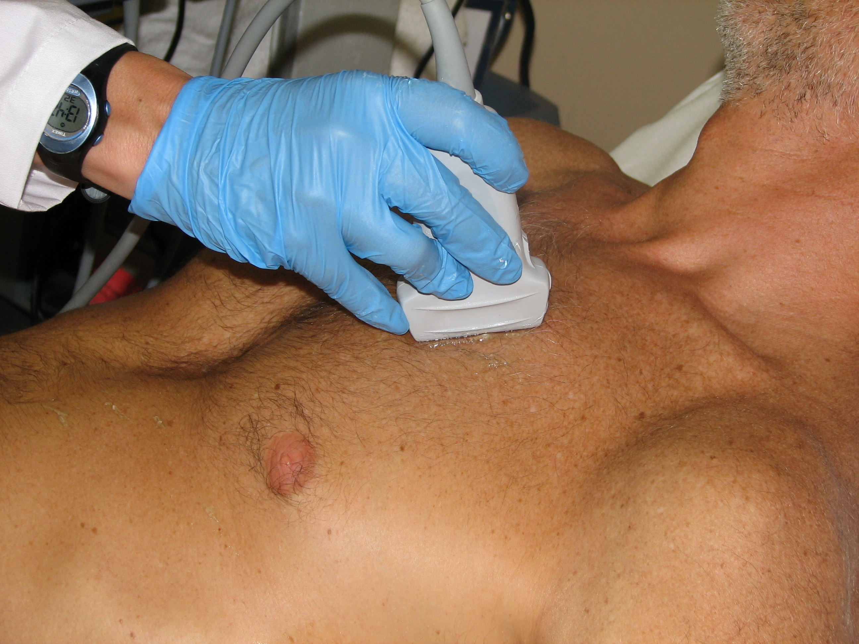

1. Anterior chest for pneumothorax

2. Anterior chest for B-lines (pulmonary edema): same placement as above but switch to abdominal (curvilinear probe)

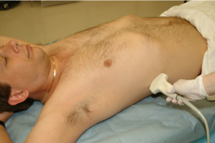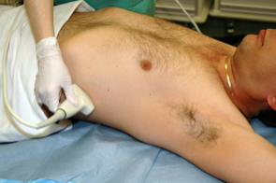
3. Costophrenic angles for pleural effusion

Fluid

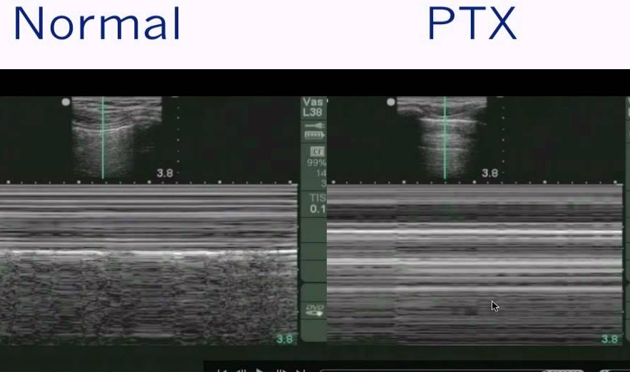
Thoracic Technique and Tips

1. Anterior chest for pneumothorax
Vascular probe preferred: probe in
mid-clavicular line, indicator towards
pt’s head. Move the probe to find the
pleural line- the first white line just
below the ribs. Look for
movement of the pleural line.
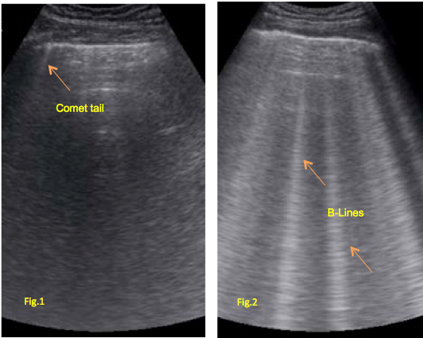
To assess in M-mode, hit “M-mode”
and use the mouse pad to move the line
so that it intersects the pleural line, then
hit “M-mode again”. When the screen
is full, hit freeze. Look for the “waves
on a beach”. The “barcode sign”
suggests pneumothorax.
You can also perform this exam with the
abdominal (curvilinear probe)- just
decrease the depth to 3 to 4 inches so
the pleural line is in the center of the
screen. Look at multiple rib interspaces
for best sensitivity.

2. Anterior chest for B-lines (pulmonary edema)
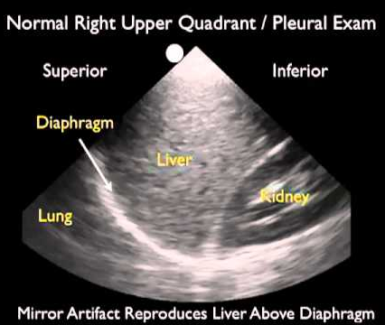
Use the curvilinear (abdominal) probe;
place the probe in the same position as for the
pneumothorax exam. Increase the depth to 15 to 18
cm and look for B-lines: bright, cone-like beams of
hyperechoic artifact that extend to the bottom of the
screen. If you don’t see them at first, try fanning the
probe slightly to see if they appear. > 4 B-lines is
suggestive of edema.

3. Costophrenic angles for pleural effusion
Use the curvilinear (abdominal) probe; place the probe
in the mid-axillary line, indicator to the pt’s head,
similar to the way you perform a FAST exam. Slide the
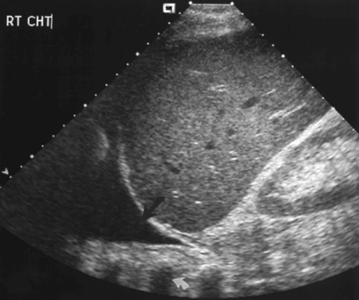
probe towards the pt’s head until you see the
diaphragm. Look for fluid (loss of the mirror artifact)
above the diaphragm.

